Exp 8 - Realization of FIR Filters Using Direct, Cascade and LinearPhase Structures Using MATLAB
Program:

clc;
clear;
close all;

% EXPERIMENT 8
% Realization of FIR Filters Using Direct, Cascade
% and Linear-Phase Structures Using MATLAB

%% STEP 1: INPUT PARAMETERS
Fs = 1000; % Sampling frequency in Hz
N = 20; % FIR filter order
L = 128; % Number of samples

% Example FIR coefficients from a Hamming-window design.
% You can replace this line with coefficients from Exp 6 or 7.
b = fir1(N, 0.25, 'low', hamming(N+1));
a = 1;

% Unit impulse input
x = zeros(1,L);
x(1) = 1;

fprintf('===== EXPERIMENT 8 =====\n');
fprintf('Sampling frequency = %d Hz\n', Fs);
fprintf('Filter order = %d\n', N);
fprintf('Number of samples = %d\n', L);

fprintf('\nFIR coefficients:\n');
disp(b);

%% STEP 2: DIRECT REALIZATION
% Apply the FIR filter directly
yDirect = filter(b, a, x);

%% STEP 3: CASCADE REALIZATION
% Convert the FIR transfer function into second-order sections
[sos, g] = tf2sos(b, a);

% Pass the signal through each section in sequence
yCascade = x;

for k = 1:size(sos,1)

% Apply overall gain in the first section
if k == 1
sectionNumerator = g * sos(k,1:3);
else
sectionNumerator = sos(k,1:3);
end

sectionDenominator = sos(k,4:6);

yCascade = filter(sectionNumerator, ...
sectionDenominator, yCascade);
end

%% STEP 4: VERIFY COEFFICIENT SYMMETRY
% Symmetric coefficients indicate linear-phase FIR behaviour
bReverse = fliplr(b);
symmetryError = max(abs(b - bReverse));

fprintf('\n===== LINEAR-PHASE CHECK =====\n');
fprintf('Maximum coefficient symmetry error = %.12g\n', ...
symmetryError);

if symmetryError < 1e-10
fprintf('The FIR coefficients are symmetric.\n');
fprintf('The filter has linear-phase characteristics.\n');
else
fprintf('The FIR coefficients are not perfectly symmetric.\n');
end

groupDelay = N/2;
fprintf('Expected group delay = %.2f samples\n', groupDelay);
fprintf('Group delay in seconds = %.6f seconds\n', ...
groupDelay/Fs);

%% STEP 5: COMPARE REALIZATION OUTPUTS
difference = yDirect - yCascade;
maxError = max(abs(difference));

fprintf('\n===== REALIZATION COMPARISON =====\n');
fprintf('Maximum direct-cascade output error = %.12g\n', ...
maxError);

if maxError < 1e-8
fprintf('Direct and cascade realizations agree.\n');
else
fprintf('Check the cascade implementation and coefficients.\n');
end

%% STEP 6: FREQUENCY AND PHASE RESPONSE
[H,f] = freqz(b, a, 2048, Fs);

magnitudeDB = 20*log10(abs(H) + eps);
phaseDegrees = unwrap(angle(H))*180/pi;

n = 0:L-1;

%% STEP 7: DISPLAY ALL GRAPHS IN ONE FIGURE
figure('Name','Experiment 8 - FIR Realization', ...
'NumberTitle','off');

% Plot 1: Impulse responses
subplot(2,2,1);
stem(n, yDirect, 'b', 'filled');
hold on;
stem(n, yCascade, 'r--');
grid on;
xlabel('Sample index n');
ylabel('Amplitude');
title('Impulse Response');
legend('Direct','Cascade','Location','best');

% Plot 2: Output comparison
subplot(2,2,2);
plot(n, yDirect, 'b', 'LineWidth',1.4);
hold on;
plot(n, yCascade, 'r--', 'LineWidth',1.4);
grid on;
xlabel('Sample index n');
ylabel('Output');
title('Direct vs Cascade Output');
legend('Direct','Cascade','Location','best');

% Plot 3: Magnitude response
subplot(2,2,3);
plot(f, magnitudeDB, 'LineWidth',1.4);
grid on;
xlabel('Frequency (Hz)');
ylabel('Magnitude (dB)');
title('FIR Magnitude Response');
xlim([0 Fs/2]);
ylim([-100 5]);

% Plot 4: Phase response
subplot(2,2,4);
plot(f, phaseDegrees, 'LineWidth',1.4);
grid on;
xlabel('Frequency (Hz)');
ylabel('Phase (Degrees)');
title('Unwrapped Phase Response');
xlim([0 Fs/2]);

fprintf('\nExperiment 8 completed.\n');

Output:

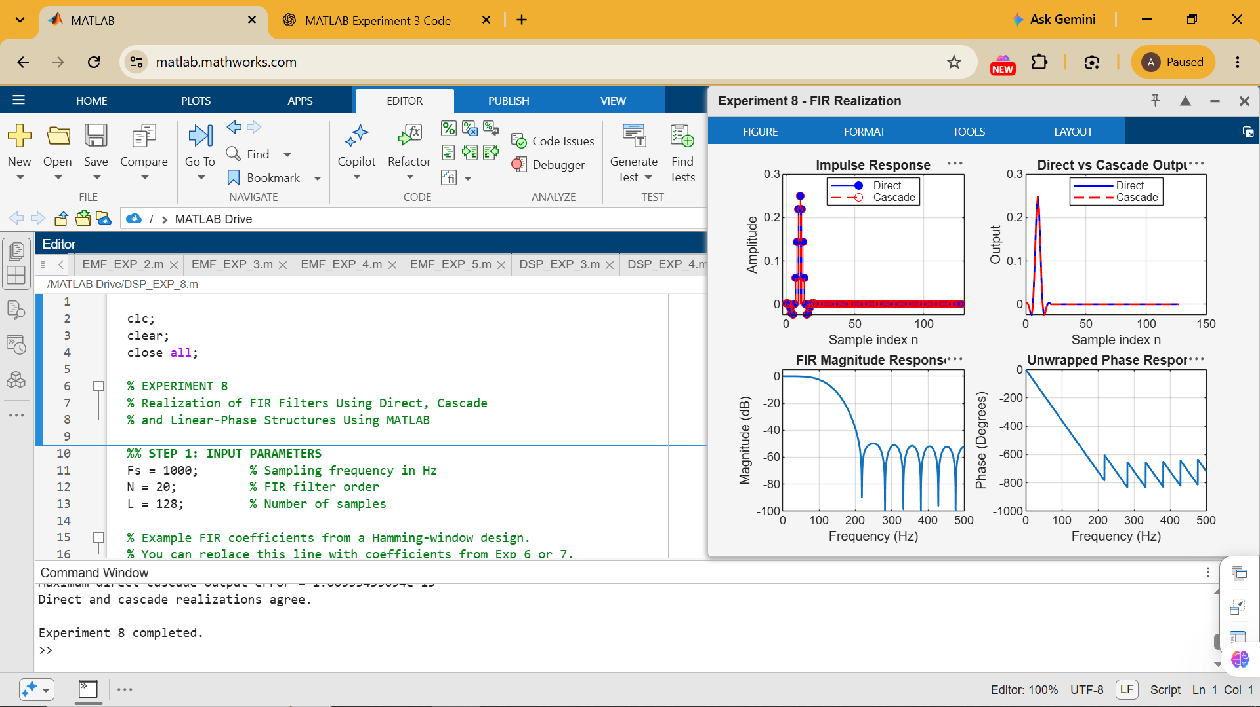

Command Window:
===== EXPERIMENT 8 =====
Sampling frequency = 1000 Hz
Filter order = 20
Number of samples = 128
FIR coefficients:
Columns 1 through 16
0.0025 0.0026 0 -0.0086 -0.0210 -0.0242 0 0.0606 0.1446 0.2191 0.2490 0.2191 0.1446 0.0606 0 -0.0242

Columns 17 through 21
-0.0210 -0.0086 0 0.0026 0.0025
===== LINEAR-PHASE CHECK =====
Maximum coefficient symmetry error = 0
The FIR coefficients are symmetric.
The filter has linear-phase characteristics.
Expected group delay = 10.00 samples
Group delay in seconds = 0.010000 seconds
===== REALIZATION COMPARISON =====
Maximum direct-cascade output error = 1.66533453694e-15
Direct and cascade realizations agree.
Experiment 8 completed.
>>

